Game Engine Comparison

Before any development begins it is vital to ensure I am going to be completing it on a platform that works to my benefit. Throughout this document I doing to be assessing several options, all of which I see as a viable options to be the foundation of my project.

With the help of Strengths, Weaknesses, Opportunities, Threats (SWOT) diagrams I am going to be breaking down the game engines to understand their strengths, all of which should aid me with development, their weaknesses that may cause problems, the opportunities they offer to produce a high quality application and finally the treats to me as a developer, given my experience and goals for the project.

Unity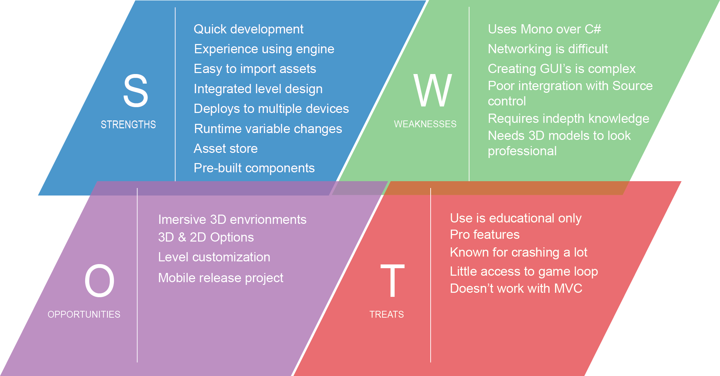

Before assessing the chosen options Unity was seen as my personal favourite. The reasoning behind this is that I have had a fair amount of exposer to Unity, although it was not to a very high standard it puts me in a better position when starting development. The main vision for the project is a 3D environment that has a chess board shaped map in the centre of the camera. I know this will be achieved without much effort using Unity due to creating similar levels in the past.

The vast amount of support that the Unity community has made available through the stack pages and their docs will aid my development. This should allow me to overcome any issues that arise during development and I would hope to relay my experience to help others by personally answering questions.

A big concern I currently have is the need for 3D model assets, I need to either create them myself or find somewhere or someone that can provide the required models. Luckily Unity has a thriving Asset store in which I may be able to buy or even better find free models to use in my game.

An issue known with Unity is its need to learn Mono, although this isn’t as bad a learning a completely new programming language it is going to cause development to slow. Along with this Unity does not have support for networking which could be an issue when I want to connect two players to the same game session. I have read that there are ways around it but the best alternative is to start from scratch and create my own. This would take up a large amount of time and I don’t know if the payoff will be beneficial enough.

One of the main problems I have previously encountered with Unity is that it does not match up well with source control, for each Unity element it will create a .meta file. These soon add up and have been labelled as the problem, however I found that the sheer size of a Unity project can be a big overwhelming for source control.

Another problem I have run into is creating a project that applies to the MVC framework. This is vital to ensure that the project is being built to be adaptable, scalable and easily to abstract. This is not the case with Unity with all of its assets being stored in the level design or used through prefabs.

## Unreal Engine

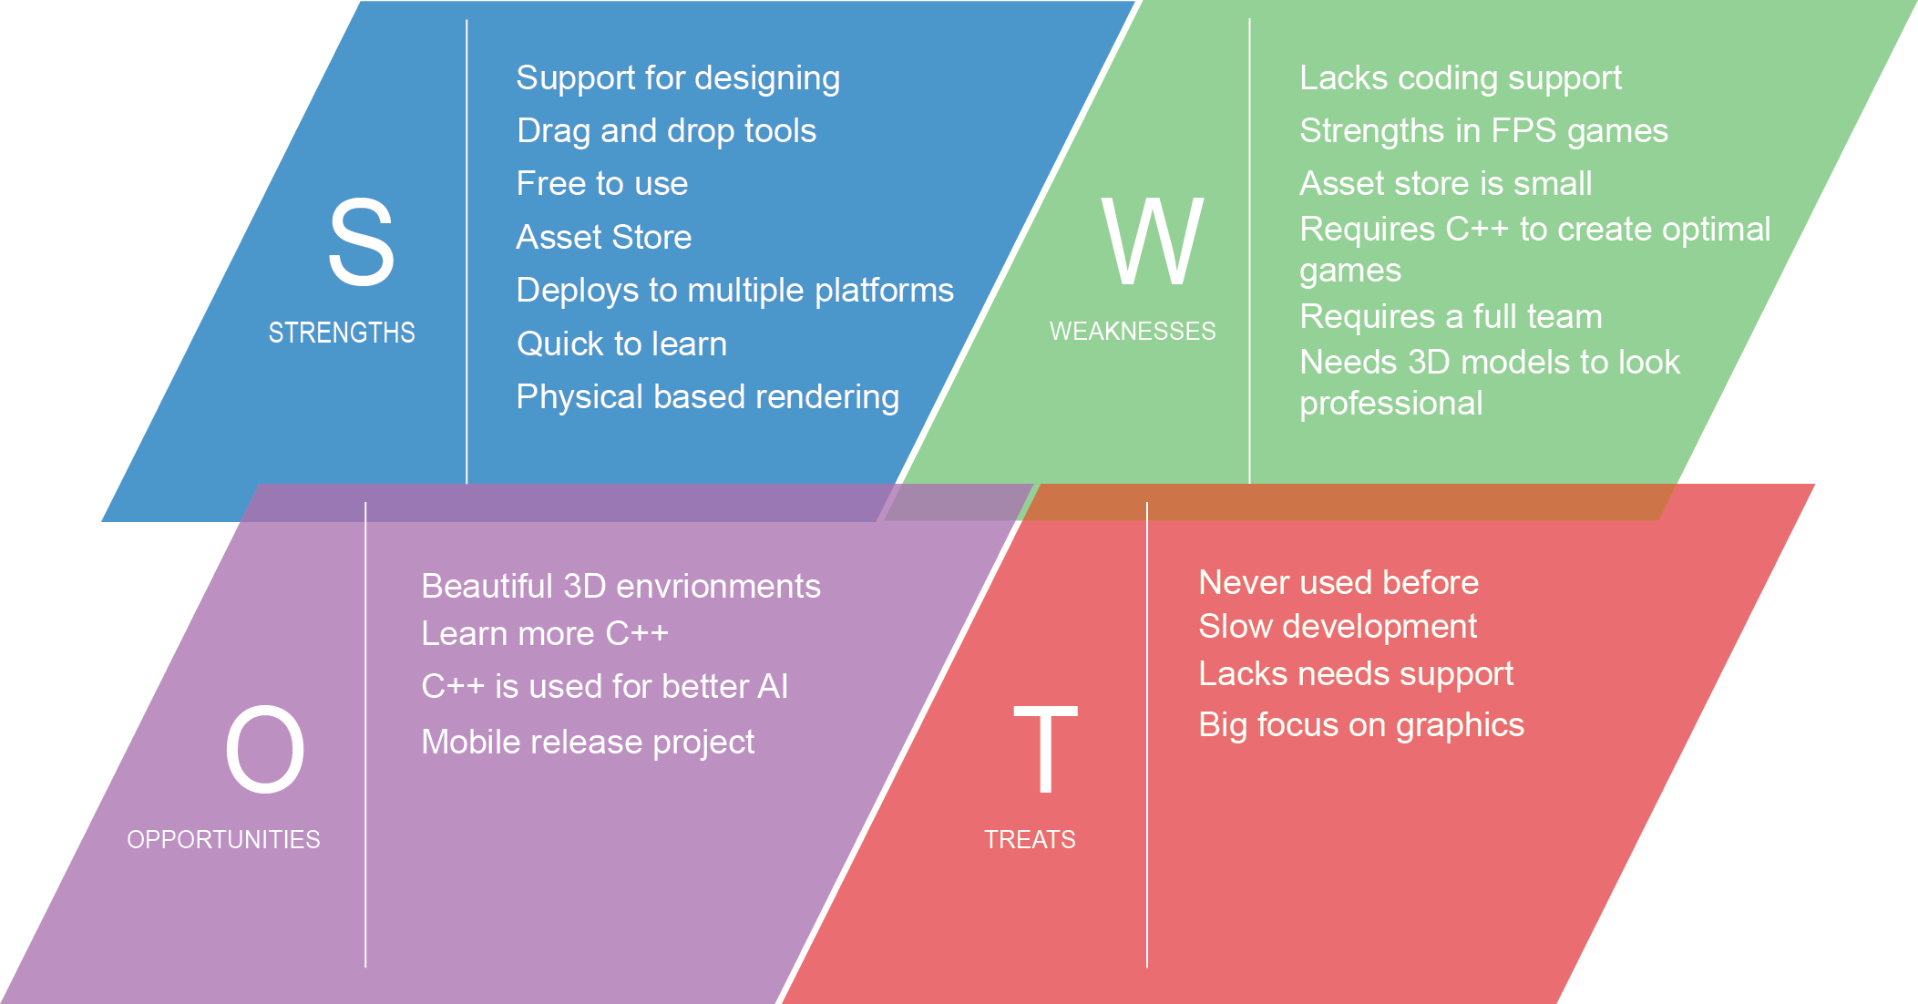

Unreal Engine has always been a strong competitor to Unity, with massive AAA releases. Due to this it was one of the engines I decided to research and asses its strengths and weaknesses towards my project and my development style.

First of Unreal games are beautiful. This is mostly because the games created on the engine are made by massive companies with hundreds of employees, however the option is there to make a game that truly is wonderful to look at. All this being said I have seen mixed reviews in regards to it being an easy engine to pick up. Some say when using the Blueprint drag and drop development tool it is a quick way to get into making your own games, however to create anything that really uses the true potential of Unreal you need to have a deep understanding of C++ and this is a massive issue for me as it has a very steep learning curve and would require a vast amount of learning before any development would begin. This being said it would be a fantastic opportunity to learn more C++. Just like Unity, Unreal has its own asset store. It has been noted that the Unity store has a lot more to offer to a beginner but this should deter me from using Unreal as there as still external resources available that can be imported.

Unreal was originally build with first person shooter (FPS) games in mind, which has had a massive effect on the games created within the engine. Seeing as my game does not require these features I am unsure it will be worth the steep learning curve required to develop a turn based strategy game.

## Adobe Air

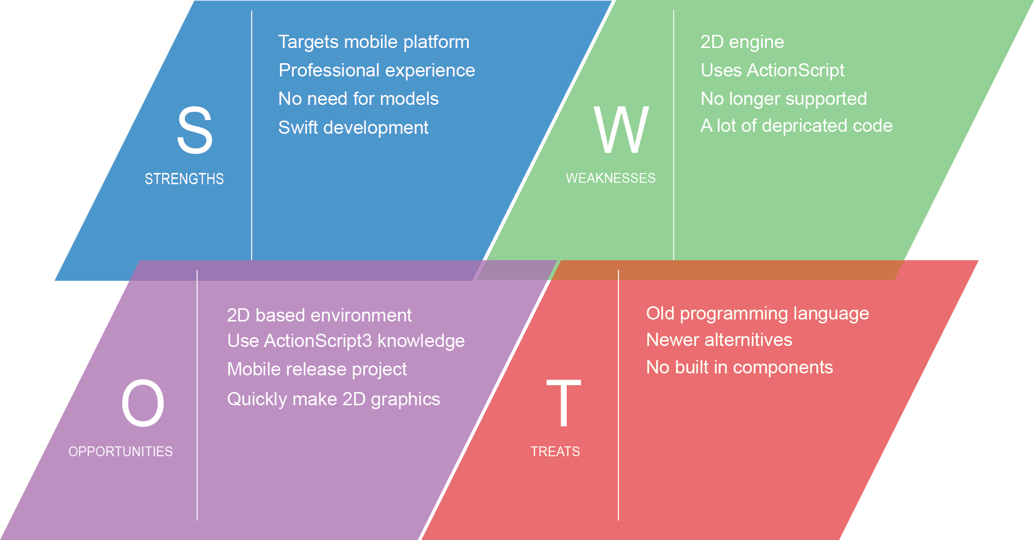

Although Adobe AIR may seem like a strange choice when looking at developing a game on this scale, however flash games have been and still are extremely popular. This still is not the only reason I decided to research about AIR. During my placement year I was part of a team that used AIR to create a very impressive whiteboard animation application. I was able to see AIR for its true potential.

Although this would limit my application to a 2D environment it would cut out a lot of the excess I have been worried about. First of all I would not have to look for or create any 3D assets. I would only be concerned with 2D assets and I am happy creating them as I have had a lot of practice in the past. Second of all I would be able to jump straight in with development seeing as I have a year’s professional experience with this platform. I already know the ins and outs of ActionScript3, meaning I could tailor the project to its pros.

All this being said Adobe AIR is now no longer being supported which is a humongous problem if I wish to take the development of the game any further in the future. Even if it is not being supported any longer the vast amount of support that has been raised in that past 20+ years is still available online, which should stop me from running into any problems with development.

## Conclusion

After researching about the three possible developing environments I personally think there is a clear winner. They all have their own strengths and weaknesses, all of which could make the project amazing or restrict it in some way.

I don’t believe that using Adobe AIR is going to help me further my developing skills and could hold me back in terms of the potential of this project. Due to this I have decided against using AIR. Which leaves either Unity or Unreal? Both of which will allow me to create a wonderful game, both visually pleasing and offering the elements needed for a solid 3D game. Due to the fact that I am more familiar with Unity and am able to program using Mono C# I have decided to use this as my game engine. I know that both of them present strong benefits but the need to use C++ in Unreal was a big turning point. C++ is a very professional programming language and used throughout the gaming community however there is a need for speed and C# mixed with Unity offers that .